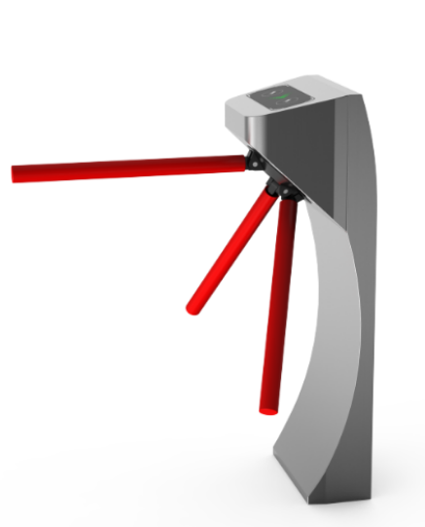

catalogue

1. Introduction to equipment 1

1.1 Brief description 1

1.2 Functional Features 1

1.3 Main technical parameters 2

2. Product overall dimensions 3

2.1 Overall dimension of the equipment 3

3. Product structure and its working principle 6

3.1 Channel gate mechanical system 6

3. 2 Channel switch electrical control system 6

3.3 Working principle of the system 6

4. Equipment installation and debugging 8

4.1 Equipment installation 8

4.2 Equipment function debugging 9

5. Common fault handling and daily maintenance of the channel gate 14

6. Equipment operation instructions 17

1. Introduction

# 1.1 Brief description

This three-roller gate is the intelligent channel management equipment developed, developed and produced by our company itself. By allocating different reading and writing equipment, we can complete the intelligent control of the passage and management of the channel.

The whole product shape with stainless steel plate stamping molding, beautiful shape, rust, durable, and system external standard electrical interface, can convenient bar code card, ID card, IC card and other reading and writing equipment integrated on this equipment, to provide orderly and civilized access and personnel, and can prevent illegal personnel in and out, at the same time in order to meet the requirements of the fire channel, in case of emergency blackout pole, organize personnel evacuation.

# 1.2 Functional Features

1) The unique incomplete gear transmission system is adopted, so that the gate lock in zero position, unlock more accurate and reliable.

2) The whole system runs smoothly and has low noise.

3) With a variety of working modes to choose from, you can read the card in both directions, or you can read the card, the other direction is banned, while reading the card, the other direction of free passage, and the gate working mode can be set through the motherboard menu.

4) With the function of power off lever and manual lever on.

5) With the function of 485 long distance control opening and drop drop to meet the special needs of users and fire safety requirements.

6) With a unified and standard external electrical interface, it can be connected to various reading and writing equipment to facilitate system integration, and can realize remote control and management through the management computer.

7) Can automatically count the number of traffic in the passing direction, and display it on the LCD screen, so that the manager knows the number of traffic in the direction of a certain direction.

8) It has a clear traffic direction indication function, with an intuitive LED walker indication that you can pass or prohibit traffic.

9) With reading card band memory and no memory function, and users can set through the motherboard keyboard according to their own needs.

10) With the automatic reset function. When reading the card, and if the traveler does not pass within the prescribed time, the system will automatically cancel the passage permission of the traveler, and the limited passage time can be set by the management personnel themselves.

# 1.3 Main technical parameters

1) Power supply voltage: AC220V± 10V, 50H z

2) Working environment temperature: -15℃ ~ 60℃

3) Relative humidity: less than 95%, non-condensation dew

4) Maximum channel width is 600mm

5) Traffic speed: 40 person / min (IC card)

6) Input interface: + 12V level signal or DC12V pulse signal with pulse width> 100ms, and drive current> 10m A

8) Communication interface: RS485 electrical appliance standard, communication distance: 1200 meters

2. Product overall dimensions

# 2.1 Overall dimension of the equipment

The varieties and specifications of the tripod turnstile gate, according to the outer shape of the chassis, can be divided into: bridge rounded corner tripod turnstile gate, bridge inclined tripod turnstile gate, bridge inclined butterfly tripod turnstile gate, bridge round arc tripod turnstile gate, bridge octagonal tripod turnstile gate, vertical round corner tripod turnstile gate and double column tripod turnstile gate 7 categories. Its appearance and dimensions are shown in the figure below.

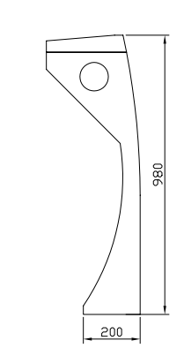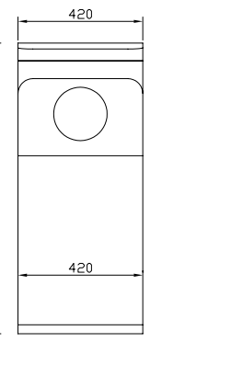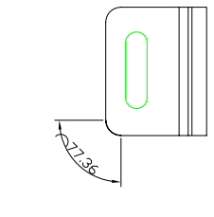

*Vertical tripod gate (420x280x980)*

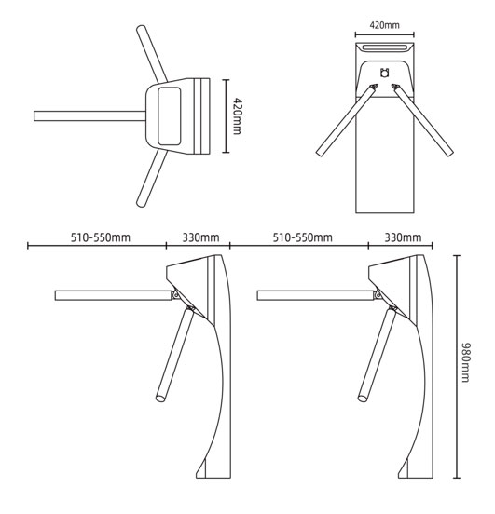

3. Product structure and its working principle

# 3.1 Channel gate mechanical system

The channel gate mechanical system is divided into two parts: chassis and movement. Chassis as a carrier, equipped with direction indicator, reading and writing device, etc.; the movement is composed of the main organic frame, movement, aluminum plate, electromagnet, gate rod, etc.;

# 3. 2 Channel switch electrical control system

7

The electronic control system is composed of card reader, main control board, direction indicator board, alarm, limit switch, transformer, etc.

Card reader (self-provided): after reading the information on the card and judging the processing, send out the application pass signal to the main control board (switch signal);

◆ main control board: the control center of the system, which receives the signals from the card reader and the limit switch, and logically judges and processes these signals, and then issues the execution commands to the direction indicator,, electromagnet, and alarm.

◆ direction indicator: display the current traffic sign status of the channel, and guide pedestrians to pass through the channel in a safe and orderly manner;

◆ alarm: when the system detects pedestrians entering the channel illegally, issue an alarm prompt;

◆ limit switch: to control the rotation position of the movement;

# 3.3 Working principle of the system

1) Turn on the power supply, and the system enters the working state after 3 seconds.

2) When the card reader reads the valid card, the peak will make a pleasant sound to prompt pedestrians to read the card successfully, judge and process the information read from the card, and send an application signal to the main control board;

3) The main control panel received the signal of the card reader, and after comprehensive processing, the direction indicator and electromagnet effective control signal, make the direction indication sign to the green arrow mark, the gate set the voice, the main control panel control electromagnet power, limit switch control movement movement Angle, allow pedestrian pushrod;

4) After the pedestrian passes through the passage according to the direction indicator sign, the limit switch senses the pedestrian passing through the passage, and sends a signal to the main control board. The electromagnet is powered off, the movement is locked, and the pedestrian cannot pass;

5) If pedestrians forget to read the card or read the invalid card to enter the passage, the system will prohibit pedestrians.

4. Equipment installation and debugging

# 4.1 Equipment installation

* Prepare the tools for installing the equipment, and count the accessories according to the packing list;
* After clarifying the system composition and working mode, the overall planning, ready to start the installation;
* After the foundation surface of the equipment is installed, arrange the equipment;
* After fixing the hole position, drill the hole, and embed the anchor bolt or expansion bolt of M12;

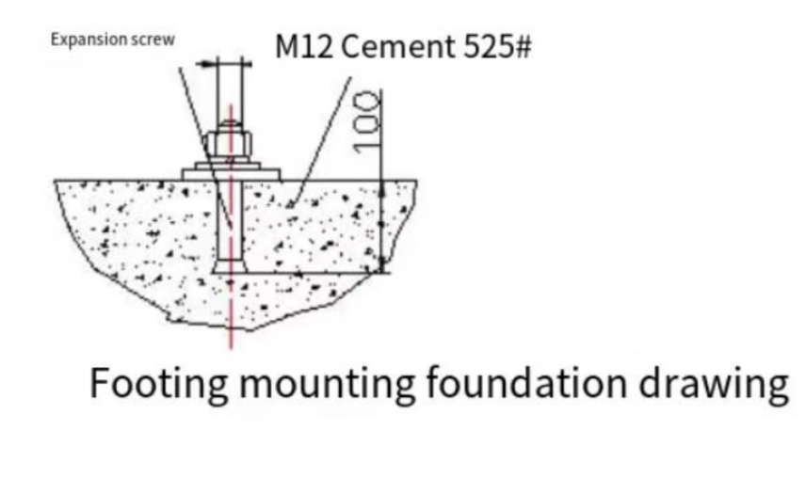

* Wear the strong electric cable and the weak current cable with 3 / 4 " PVC cable pipe respectively, and bury it in the corresponding position with cement;
* Move each chassis to the corresponding installation position, and first align with the anchor bolt position one by one;
* Check whether the system composition and working mode are correct, and then check for the next work;
* Open the chassis door, select one of the equipment as the reference reference (preferably choose the middle one as the reference reference), align the seat bolt hole at the corresponding anchor bolt, and pre-tighten the nut first;
* Open an adjacent chassis door, align the seat bolt hole with the anchor bolt, and align the fixed reference equipment, and pre-tighten the nuts; if multiple chassis bolts need to be installed, and so on;
* Refer to the wiring diagram, connect the power cord and control wire, and connect the system protection wire;
* Tighten the anchor nut after the status check and functional debugging pass;

！**warn:**

|  |
| --- |
| 1. The depth of buried PVC wire pipe should be greater than 60mm, and the ground exposure height should be greater than 50mm,  And the exit back, to the line pipe water  2. Connect to the system protection ground line;  3. If the equipment is used outdoors, a 100~200mm high cement level should be laid at the equipment installation site  Platform to separate the tide, and add the ceiling and other sunscreen, rain prevention facilities;  4. After the equipment is installed, the status inspection and function debugging qualified can be put into normal use. |

# 4.2 Equipment function debugging

**The following function debugging can be carried out only after the equipment status check is normal!**

**Commissioning instructions of the three-roller switch**

**1 Preparation before commissioning**

**Check the mainwiring according to the wiring diagram. Check that the power wiring and other wiring of the whole equipment are correct. After confirmation can be power debugging!**

**The protective ground of the equipment must be reliably grounded, otherwise it is not allowed.**

**Operation description of the system parameter setting**

**Instructions of gate panel:**

First set up the gate type (two types of power failure pole, power failure free passage).

Power outage: when the power is out, the top pole will automatically fall down, pedestrians can pass at will. After the call, first pressure the pole, and then lift the pole, the pole will automatically lock.

Parking free passage: the movement will not lock when the power is no, pedestrians can push in at will. After the call will automatically lock the movement, pedestrians must swipe the card before passing through.

**Description of setting of gate plate parameters:**

The control board shows the default status on the LCD screen after the power on the control board, and the default status shows the control board exit and the number of access times.

There are five operation buttons on the control board, including Menu Up or Down, OK or Cancel.

Keynote:

Menu: For access to the menu settings item

On: To move the menu items up

Lower: Move the menu items down

OK: Use to enter the menu item settings or to determine the current modified value

Cancel: Use to return to the previous level menu or to cancel the current operation

Menu operation:

Press "Menu" to enter the password input interface. The default password is: up and down. Enter the 6-bit password and press OK to enter the menu. After entering the menu, press "Up" and "Down" to select a function menu and then press "OK" to enter the function or value change interface, and select or adjust the corresponding value by pressing button.

Example: to change the gate working mode: enter the menu, select the menu "gate working mode" —— press "OK" (show the current working mode) —— and then press "OK" to enter the modified working mode selection interface —— press "up" or "down" to select the corresponding working mode —— press "OK" to modify the successful —— set completed press "cancel" exit (do not press the cancel key, the system will automatically exit after 15 seconds).

1. System menu description:
2. "Entry and exit direction configuration":

Set the gate left is the entrance or exit; the right is the entrance or exit.

1. "Entrance and exit traffic configuration":

Whether both sides of the gate (entrance and exit) are allowed to pass.

1. "Entry and exit Memory function configuration"

Open or close the entrance and exit to pass whether has the memory function, generally used for the swipe card to open the gate, in a person swipe card has not passed, whether to remember the credit card of others."Forbidden" is the first person passed after the second person swipe card is valid; "allowed" is how many consecutive individuals are allowed to pass.

1. "Entry and exit opening time"

After setting the opening, no traffic, the gate automatically close the time.

1. "Gate working mode". Set the gate is power off off the pole, or power off free passage.
2. "Statistical counting mode"

The setting count is subject to either the opening signal or the opening signal. Usually, without special requirements, the opening signal shall prevail.

1. "Counter reset"

Empty entrance / exit passes, recount.

1. "Equipment machine number"

Equipment number of the control board. Generally do not set up.

1. "facility information"

Display the basic information of the control board, such as type, model, etc

1. "system initialization"

Initialize control board parameters, after successful initialization, control board parameters resume factory settings.

1. "Left-hand traffic voice"

Set the voice required to play at the gate when passing from the left. For example: from the left when let the gate play "welcome".

1. "Right-side traffic voice"

Set the voice required to play by the gate when passing from the right. Such as: let the right side of the gate play "a safe way".

1. "Test voice"

Automatically play the voice inside the control board in turn, and automatically exit after playing.

1. "Test Electromagnet"

Whether the three roll gate can work normally depends on the electromagnet. As long as the electromagnet can work normally, and the mechanical part is not abnormal, the three roll gate can work normally. This keeps the electromagnet 50 times.

|  |
| --- |
| Note: 1. No peripheral equipment shall be added to the system without permission;  2. If the commissioning results are inconsistent with the described functions during commissioning, please refer to the Common Troubleshooting section. |

5. Common fault handling and daily maintenance of the channel gate

**５.1 The rear direction indicator and LCD display are not displayed, and the card cannot be read**

The fault is mainly due to the power supply system of the equipment, so we should carefully check whether the safety pipe of the equipment main controller is damaged, whether the connector is loose, and whether the power cord is broken

**5.2 Occasionally, the pole drop phenomenon occurs during the use process**

There are two main reasons for this failure:

A 2 internal hexagonal screws in M4 fixing the rod electromagnet are loose. The exclusion method is follows:

1) Open the upper lid of the case with the key;

2) Loosen 2 M4 hexagonal screws fixing the rod electromagnet;

3) Gently move the stripping rod electromagnet up a little;

4) Tighten the 2 M4 internal hexagonal screws of the stripping rod electromagnet;

5) Check whether the fault is eliminated, otherwise repeat the method described in 2) ~4) until the fault is eliminated;

Insufficient stretch in B gate (see figure below)



For this fault, we should timely notify our after-sales service department or authorized service agency for replacement.

**5.3 The switch rod can not be reliably locked on or during use**

The fault is mainly caused by the stripping rod electromagnet damage or broken wire, loose wiring situation, or the shrapnel as shown in the figure above fracture.

**5.4 Read a card, can continuously through multiple people**

The fault is mainly caused by the following reasons:

The signal output by the user card reading system to the gate master controller is unstable (with jitter, such as the relay), and the gate reading system is working in the card reading and memory working mode. The fault can be eliminated by the following methods:

A) Switch the working mode of the switch to the card reading without memory mode;

One second delay for b) to the signal output from the control system;

2) The reset pull spring of the positioning arm fails or the pull force is not enough, so that the positioning arm cannot be reliably reset and locked.

**5.5 Cannot read the card normally**

The fault is mainly the loose wiring between the card reading equipment and the main controller or the card reading equipment is damaged. After replacing the card reading device.

**5.6 The card reading is normal, and the direction indication is allowed, but it is not passable**

This fault is mainly caused by the following reasons:

1) Synsynchronous tooth belt fracture- - - - - -Model: 222-3M-6 synchronous tooth belt replace the broken synchronous tooth belt.

2) The 5A insurance pipe on the main control plate of the three-roller gate is damaged

3) Damaged electromagnetic iron or loose wiring

When the electromagnet is damaged and the electromagnet is replaced, the electromagnet must be checked before the equipment enters into use.

4) The main control plate of the three-roller gate is damaged

When the electromagnet or the main control board is damaged, we must immediately notify our after-sales service department or authorized agency for processing.

**5.7 After reading the card and passing through, it is unlocked in the other direction**

The fault is mainly caused by the left and right electromagnets connection, the left and right electromagnets plug exchange, you can solve the above problems.

6. Equipment operation instructions

6.1 Before the equipment is put into use, it must be put through functional commissioning;

6.2 When the equipment is powered on, the rod should be manually pressed and the rod mounted; free passage is not needed.

6.3 When pedestrians read the card, the direction indicator sign does not turn green, and it is strictly prohibited to enter the channel;

6.4 When pedestrians pass through the passage, do not stay in the middle of the passage for a long time;

6.5 When passing the gate, do not crowded, should keep a certain distance between people;

6.6 Do not read the card, and pass through the gate quickly;

6.7 It is suggested to mark the local passage instructions in the conspicuous place of the equipment work, and guide the pass walker to pass through the gate channel in a safe and orderly manner;

6.8 The equipment should not be properly managed, and it is strictly prohibited to knock and shake the equipment;

6.9 When the equipment is in the closed state, it is strictly prohibited to push and pull hard or impact the gate rod;

**! warn:**

|  |
| --- |
| 1. **Do not use the machine when there is lightning, to prevent damage to the machine;** 2. **To ensure that the system is protected and reliably connected, in order to prevent personal injury;** |

abc

1. Limit photoelectric switch: 3 lines, including 2 power inputs, brown: + 12V, blue: GND and 1 signal output, + 12V when the sensor head touches a magnet or metal object (sensor distance of 1-2mm), and 0V otherwise.

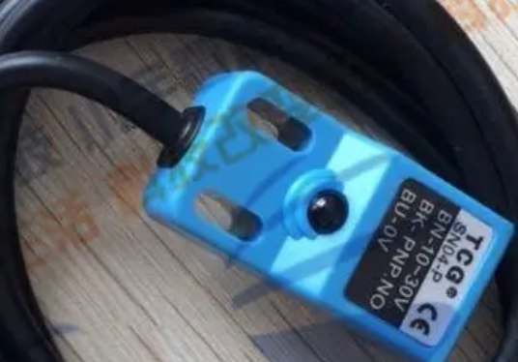

B. Assembly of the gate rod

1) Put the gate rod into the aluminum plate mounting tank;

2) Put the pin into the aluminum plate pin hole;

3) Put the pin in place and tighten the screws.

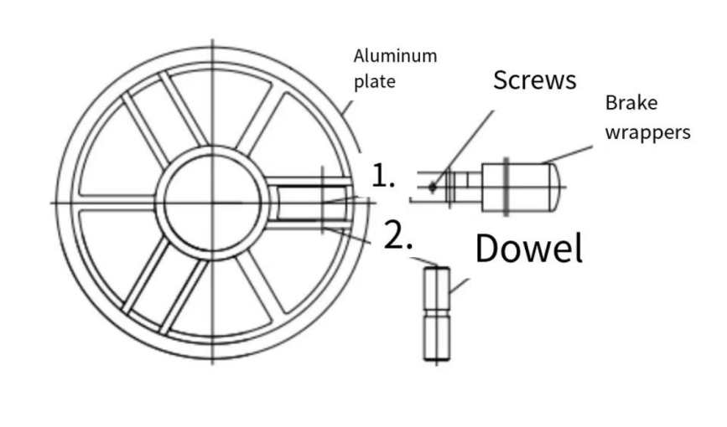

**gate wiring diagram**

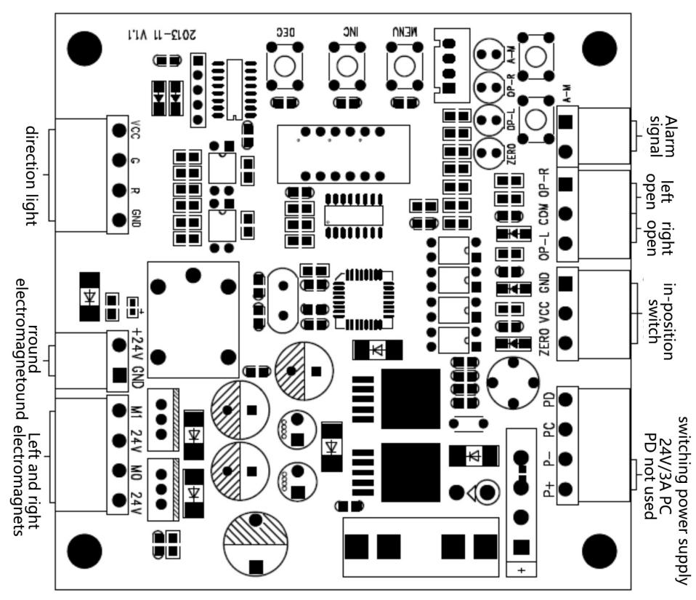

！**pay attention to:**

**It is forbidden to take power from the main control board to supply other equipment privately, and the damage caused by the circuit board is not covered by the warranty.**

**User data card**

|  |  |  |  |  |  |
| --- | --- | --- | --- | --- | --- |
| customer name |  | contact number |  | zip code |  |
| customer address |  | | | | |
| Machine model |  |  |  |  |  |
| Sell machine unit |  | contact number |  | zip code |  |
| Sell machine address |  |  |  |  |  |
| Date of sale |  |  |  |  |  |

maintenance record

|  |  |  |  |  |
| --- | --- | --- | --- | --- |
| Delivery date | Fault description | Maintenance treatment | Maintenance of the people | Seal of maintenance unit |
|  |  |  |  |  |
|  |  |  |  |  |
|  |  |  |  |  |
|  |  |  |  |  |
|  |  |  |  |  |
|  |  |  |  |  |
|  |  |  |  |  |
|  |  |  |  |  |

Note: The authorized maintenance unit shall carry out the maintenance, fill in the maintenance record and stamp the official seal, otherwise the maintenance record will be invalid

**Warranty instructions**

* Within one year from the date of purchase, the company will be responsible for free maintenance.
* During the warranty period, any fault caused by the quality problems of the product itself, please bring the filled out warranty card and purchase invoice in the company authorized by the maintenance center for free repair, or send back to the company.
* For faults or damage caused by man-made or natural disasters during the free maintenance period, the maintenance cost shall be charged;
* Maintenance costs are charged for maintenance services outside the free maintenance period.

The following conditions are not covered by the warranty

* Damage caused by abnormal operation and man-made or natural disasters;
* Remove age replacing any part of the machine (such as lines and parts);
* Failure caused by installation by our designated professional technicians
* Do not receive machines due to unauthorized modification or installation of other functions.

Note: Save the warranty card and the purchase invoice as the warranty certificate of this machine, please keep it properly.